Date: -15/10/26
CO-1 Assessment-3
APPLICATIONS BASED QUESTIONS
Course Code: -DSA 0308
Course Name: -Natural Language Processing
Name: -A.V. Ameya Reg no: -192472036

1. Intelligent Email and Password Validator Using Regular Expressions
Introduction
In today's digital world, email addresses, passwords, and mobile numbers are widely used in websites, mobile applications, and online registration systems. Validating these details is important to ensure that users enter information in the correct format. Incorrect inputs may cause registration failures or create problems during authentication.
Explanation
First, the email address is checked to determine whether it follows the specified format, including a username, the @ symbol, and a valid domain extension. Next, the password is checked for minimum length, uppercase and lowercase letters, digits, and special characters. Finally, the mobile number is checked to ensure that it contains ten digits and begins with an appropriate digit.
Algorithm
- Start the program.
- Import the re module.
- Get email, password, and mobile number.
- Validate each input using regular expressions.
- Display the validation results.
- Stop the program.
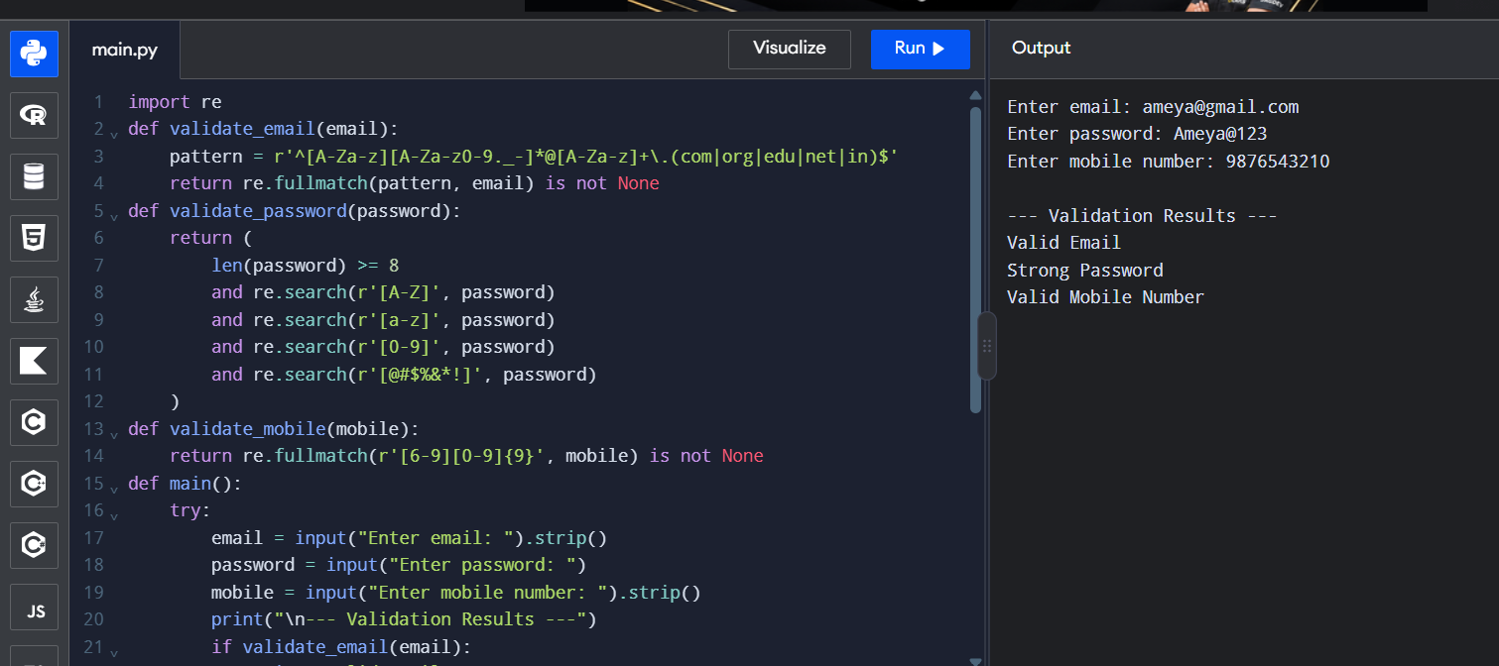

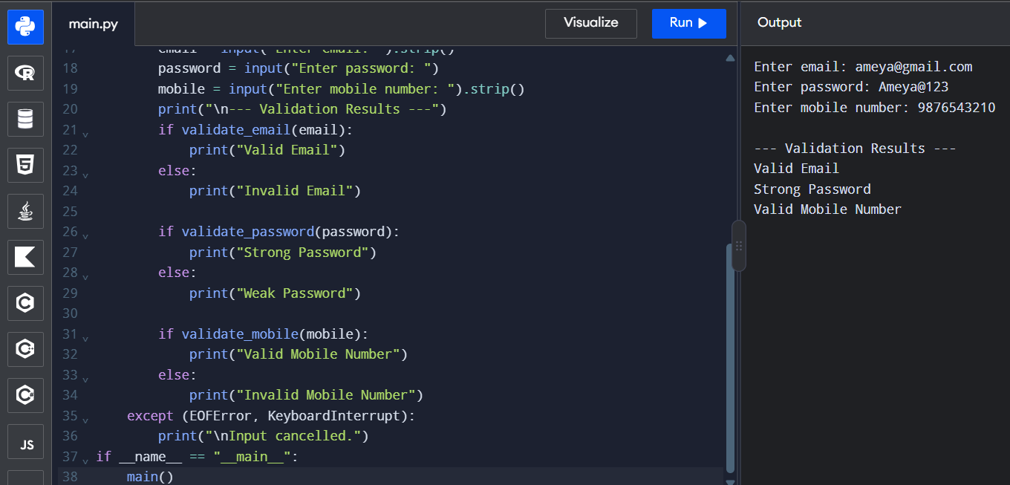

Result
The program successfully validates email addresses, password strength, and mobile numbers using regular expressions. It displays whether each input is valid or invalid.
2. Design a Finite State Automata (FSA) Simulator
Introduction
A Finite State Automaton (FSA) is a mathematical model used in computer science to recognize patterns and process sequences of symbols. It consists of a finite set of states, an initial state, transition rules, and one or more accepting states. Finite State Automata are important in theoretical computer science and are widely used in compiler design, lexical analysis, text processing, and pattern recognition. A Deterministic Finite Automaton (DFA) has exactly one possible next state for each state and input symbol.
A simulator helps students understand how automata process strings and change states according to predefined transition rules. By implementing an FSA in Python, the behaviour of a theoretical automaton can be demonstrated through a practical program.
Explanation
The program reads the input string one character at a time. Depending on the current state and the character being processed, it moves to the next state according to a transition table. For example, when the program reads the character a, it moves to a state that tracks the possibility of finding the required ending. When the following character is b, it reaches the accepting state. After processing all the characters, the program checks the final state. If the final state is q2, the string is accepted because it ends with ab. Otherwise, the string is rejected.

Algorithm
- Start the program.
- Initialize the DFA states and transitions.
- Get a string from the user.
- Read each character and change states accordingly.
- Check the final state.
- Display Accepted or Rejected.
- Stop the program.
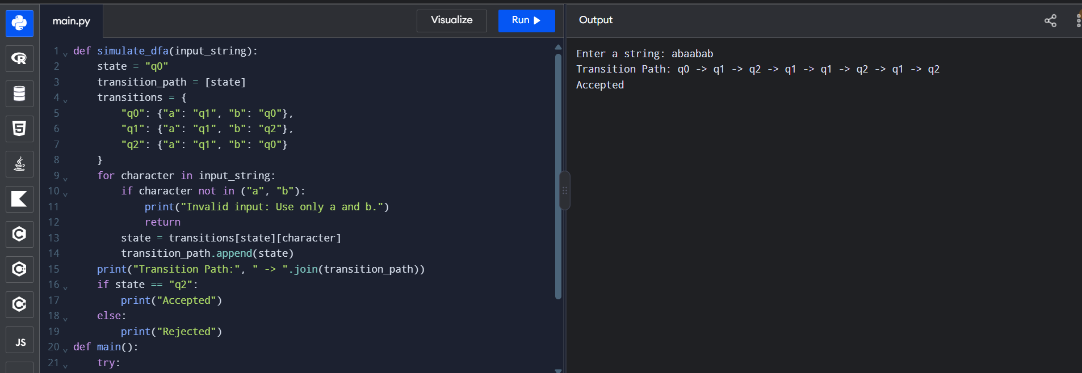

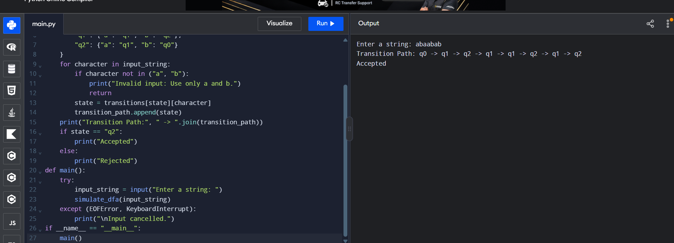

Result
The program successfully simulates a DFA to check whether a string ends with ab. It displays the transition path and determines whether the input string is accepted or rejected.

3. Smart Pattern Matching Engine Using Regular Expressions
Introduction
Text processing is an important area of computer science that involves analysing, searching, and extracting useful information from textual data. Large amounts of text are generated through emails, websites, social media platforms, and digital documents. Manually searching such text for specific information can be time-consuming. A Smart Pattern Matching Engine applies these concepts to create a simple, menu-driven text analysis program. It allows users to select a search operation and obtain matching results from the given text.
Explanation
The Smart Pattern Matching Engine accepts a text string from the user and displays a menu containing six search operations. These operations include searching for dates, phone numbers, hashtags, mentions, prefixes, and suffixes. When the user selects an option, the program chooses the corresponding regular expression. For date searching, it identifies strings that follow the specified date format. For phone number searching, it looks for ten-digit numbers beginning with an appropriate digit. Hashtag and mention searches identify words beginning with # and @, respectively.
The program uses the re.findall() function to collect matching patterns from the text. The re.escape() function is used when incorporating user-provided prefixes or suffixes into a regular expression, preventing special characters in those inputs from being interpreted as regex operators. Finally, the program displays the matching results or an appropriate message if no matches are found.
Algorithm
- Start the program.
- Import the re module.
- Get text from the user.
- Display the search menu.
- Select a pattern based on the user's choice.
- Search the text using regular expressions.
- Display matching results or a message if no match is found.
- Stop the program.

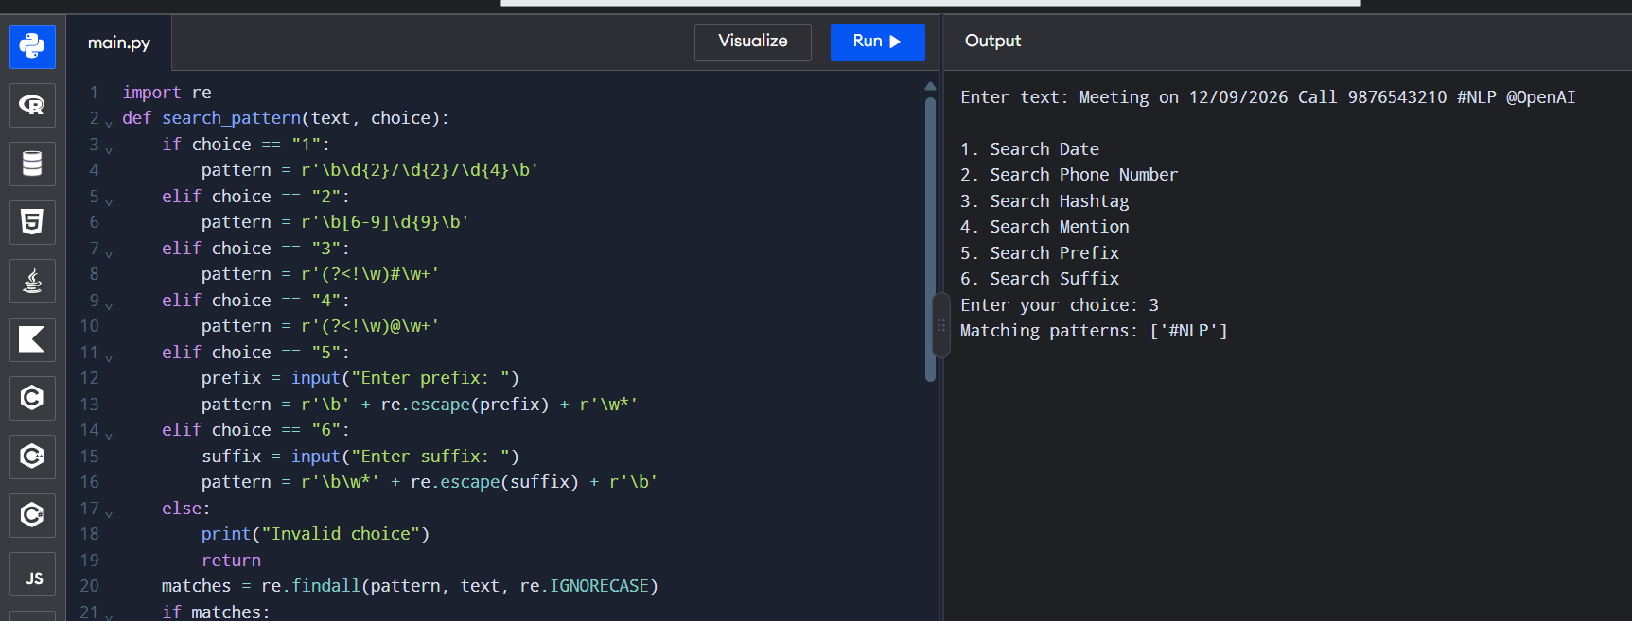

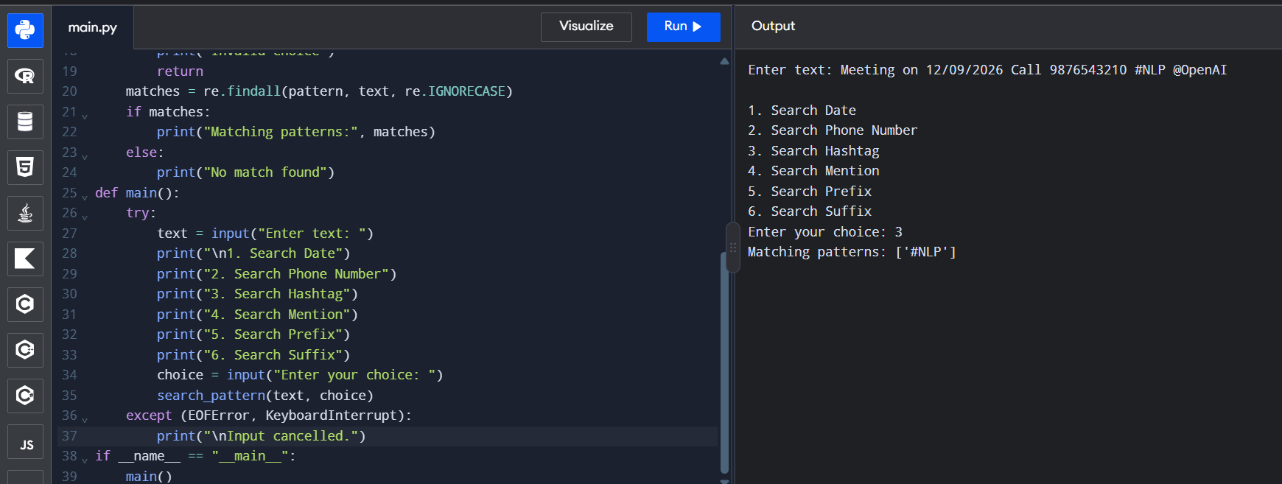

Result
The program successfully searches text for dates, phone numbers, hashtags, mentions, prefixes, and suffixes using regular expressions. It displays the matching patterns or a message if no match is found.

